To add a new server, there is one part you do on the server, and another part within the HA SQL Server application

SQL Server Management Studio

---------------------------------------------------

* Remote to server HLA6, or go to the server itself and login if you are in Dedham
* Open SQL Server 2008 Management Studio, connect with ‘Windows Authentication’ (shown below) , not SQL Server Authentication.

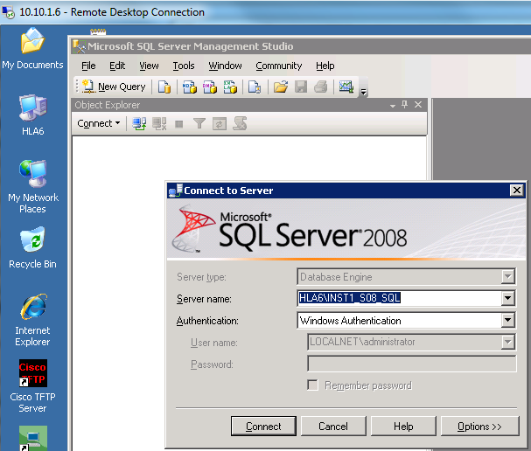

Add the login

-----------------------------------

* Expand the Security folder that is shown under the HLA6 server (not under any database). See below
* Right-click the ‘Login’ folder, choose Add Login

Login name: <enter name>

Click SQL Server authentication

Enter the password and confirm password

Uncheck 'Enforce pw policy', pw expiration, pw change

Default database: HLA_LIVE

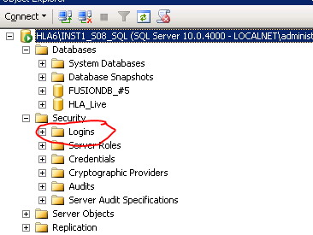

Add the database user

----------------------------------------------------------

* Expand ‘Databases’, then expand database HLA_LIVE
* Select folder Security > Users
* Right-click to Add user

Username: YU

Login: YU

Schemas owned: HLA_LIVE

Database role membership: hla_user (need to scroll down to see this role)

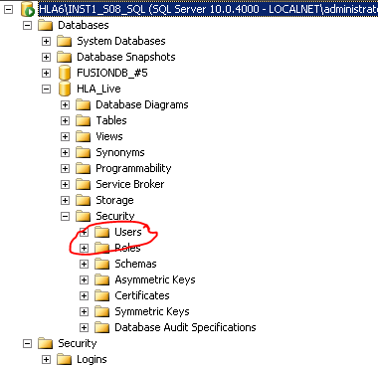

To check that this user can login:

* Right click the server instance and select ‘Disconnect’
* Connect again, this time selecting ‘SQL Server Authentication’
* Enter the username and password you just set up.
* If successful, close SQL Server

This is all you need to do on the server.

Create the user in HLA SQL server

* Log into HLA SQL Server (the HLA application)
* Select Data Entry > Admin > Codes.
* Select EMPLOYEE in the left pane (See below)
* Click the button ‘Add a NEW code’
* In the new row, enter the employee name LAST, FIST and short name
* (Important) In the lower window, enter the login name on the Oracle row, and the user’s security level on the Security Level row. The login must be the same as the one you entered on the server. Example: The login ALOSCO shown below connects to a SQL Server login ALOSCO created on the server.

